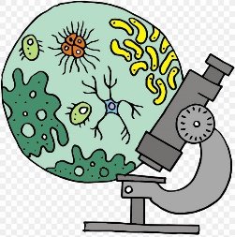
Biology with Labs

Class Syllabus

Primary Instructor: Jennifer Stone

Text: Apologia Exploring Creation with Biology, by Jay Wile, 3rd Edition

Course Description:
This college-prep biology course provides students with a thorough understanding of the relevance of scientific inquiry. Textbook readings are backed by hands-on experiments that take students' book knowledge and bring it into real-world applications. After completing this course, students will be able to understand the vocabulary of biology and gain a strong understanding of the scientific method that will equip them to analyze data across other disciplines.
Modules cover atoms, chemical structures, ecosystems, biomes, ecological communities, cell structure and function, cellular energy, DNA, proteins, cell cycles, and genetics (including inheritance, disorders, and technology). Students will also learn about prokaryotes, viruses, protists, fungi, and the fascinating worlds of plants and animals.
Lab Component (30% of grade) will provide the student opportunities to explore Biology by hands-on projects, dissections, microscope work, and lab experiments utilizing the Scientific Method of experimentation. Students will gain a basic understanding of the way things work in the amazing world God created. Students will have opportunity to learn how to think like a scientist as they set up experiments and explore variables, and foster an environment to spark students’ enjoyment of Biology.

Labs included:

Scientific Method
Rules of Experimentation
importance of documentation of observations
Experiment variables/Control
Introduce Microscope
Cells, Parts of the cell
Microscope Use
Cell Model
Energy Metabolism of the cell
Lipids, proteins, enzymes, energy
Cellular chemistry
Osmosis labs
Classification of Living things
Characteristics of Living/non-living
Genetics

Dissections included:

Earthworm
Starfish
Leopard Frog
Crayfish
Fetal pig
perch

Class Assessment:
- Student lab notebook (labs, dissections, labelling) 30%
- Projects, tests, presentations, collections 20%
- Homework 30%
- Active Class Participation ** 20%

Grading Scale*:
A 90-100 B 80-89 C 70-79 D 60-69 F Below 60
*Grade calculated according to 2016 South Carolina 10 Point Grading Scale

